**UML Assignments**

Q1 Uml class airline reservation system.

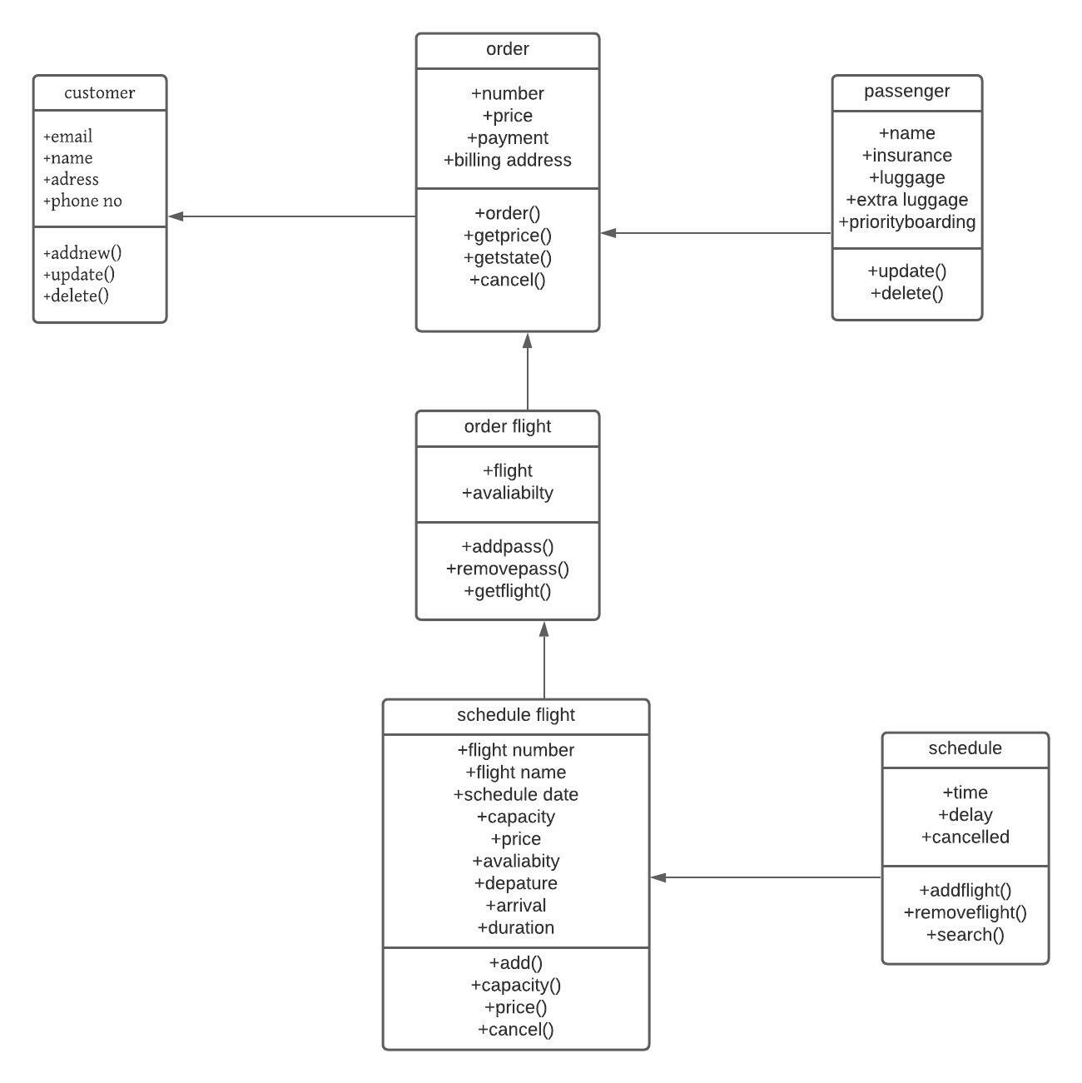

Q2. Uml class diagram of university

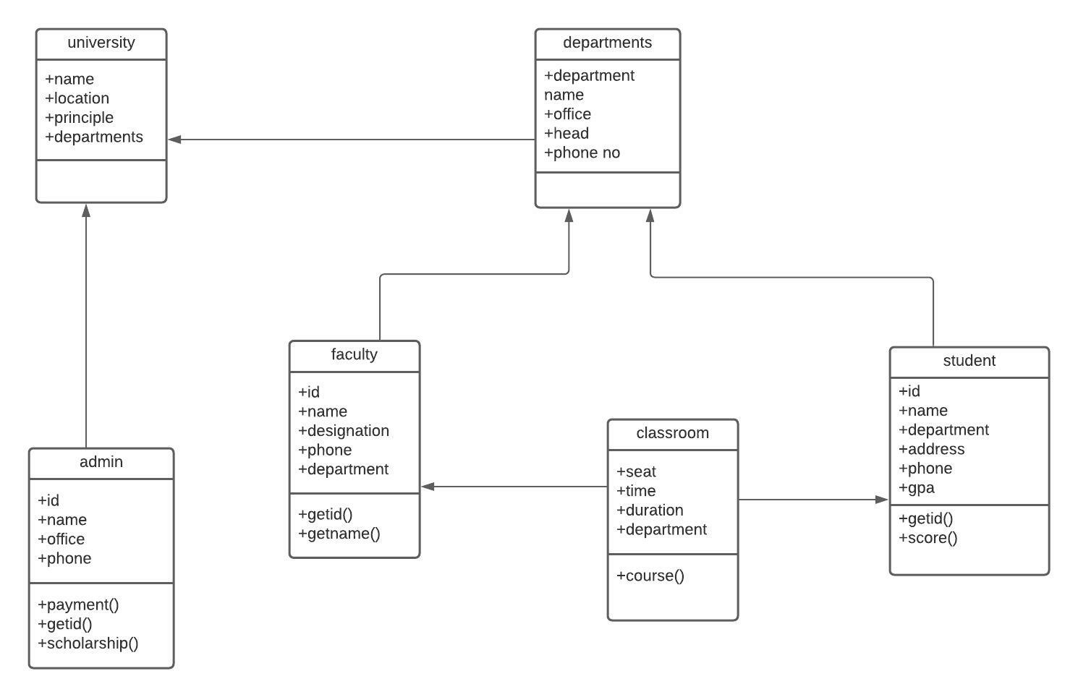

Q3.activity diagram for the given scenario where a student needs to enrol with the university for the given course.

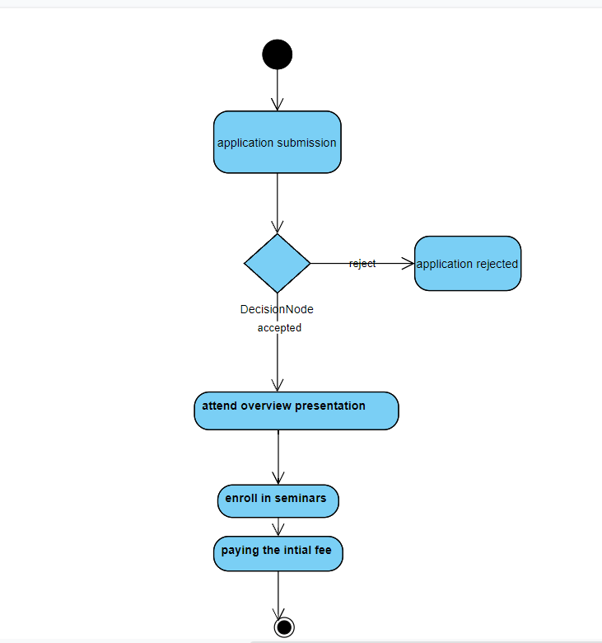

Q4. sequence diagram Online Library Management System